Ralph Mora

Assignment 6.2

ECE 495

First, we represent our data with a = 0.2 and a = 1.5



Now that we can visualize our data, we need to create a function that will compute the kernel matrix k(Xi,Xj) = (XiT*Xj+1)3 is the dot product of the Volterra expansion of the two vectors

**3rd Order Volterra Expansion**

Then we put all these elements together and that gives us a vector in a 10-dimensional Hilbert space. Then we program a linear estimator using the function = wT(xn), where (xn) represents our 10-dimensional vectors, and is the predicted y value. wT is linear in the function so we can find the mean squared error and minimize it.

w =( *T )*-1

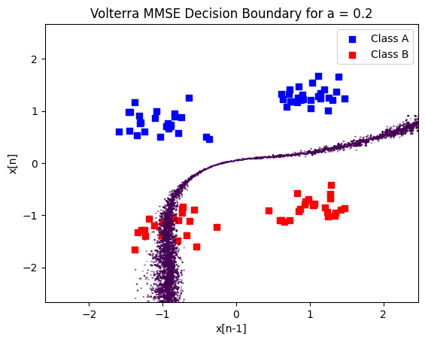

Since the alpha coefficients are on the order of 1e13 evaluating it gives very unstable results.

We now compute the Ridge Regression solution =(K+yl)-1y, and for now we set y equal to 0.1 and when we compute the solution, we can see clear classifications in bot a = 0.2 and a =1.5

Experimenting with the y value, I noticed that when y gets closer to .1e-12, we begin to create unstable classifications again.

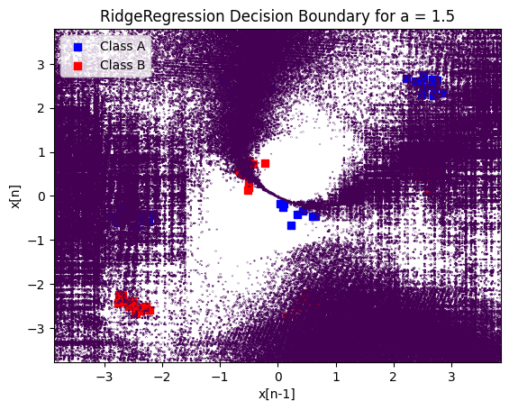

This is because the magnitude of the elements when we convert them into a 10-dimension vector are at least 10^12, and the order of magnitude for the weight’s change from 10^13 when y = 0 to 10^8 when y = 1^-10, This is still a large number and that is why regularization is needed.